Dear Valued Client,

We are proud to announce that we are now offering equine telehealth services to our clientele. This means that you will be able to instantly solicit veterinary assessment whenever you want… right from your smartphone. It also means that we will be able to evaluate your horse on a continuous (rather than an episodic) basis. This permits us to stay ahead of problems that might develop with your horse(s) and is the foundation of an effective wellness program. In the end, our administration of telemedicine will help your horses stay happier and healthier for longer.

Our service is supported by GetSound®, the premier provider of equine telehealth solutions worldwide. Please go HERE to sign-up. Alternatively you can sign-up using the GetSound® App, which is available both in the App Store (iOS) and on Google Play (Android). The GetSound® App and your GetSound® membership are FREE; there are no up-front or subscription fees.

Once registered, you can update your profile and add all of your horses to your account: this will streamline future communications with us and enable us to track of each of your horse’s veterinary care independently.

How it Works

Whenever you have a question or concern regarding one of your horses, simply upload the details and corresponding images (videos, photos, x-rays, etc.) with your submission. This can be performed directly from your smartphone. We encourage you to submit consultation requests on a regular basis so that we can keep track of your horses’ health and detect problems promptly. This will not only improve the prognosis for your horse(s) but will save you considerable time and money in the long-run. Each of your submissions will immediately generate an email notification on our end, telling us that you’re awaiting a response. | 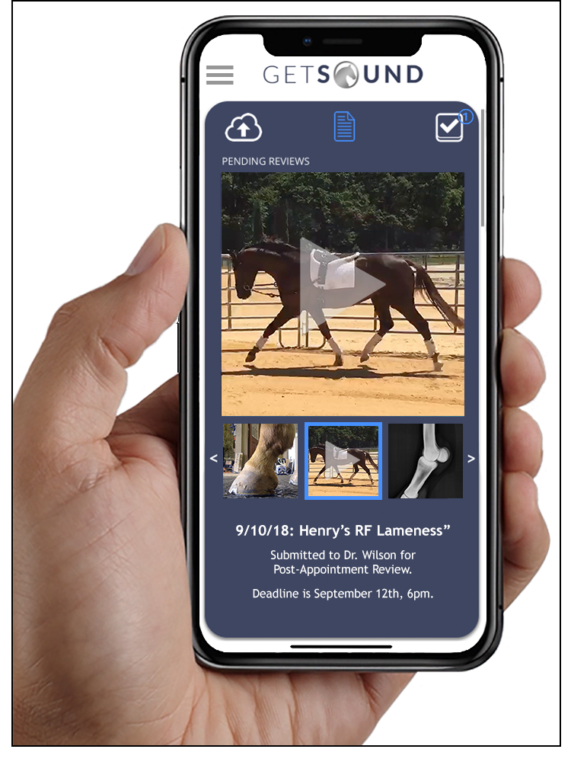
You will be notified (via a return email notification) as soon as we’ve completed our telemedical review. At that point, your report will be directly available through the app on your phone. All records and images relating to each consultation will be securely stored within your account and will remain accessible in the cloud indefinitely. This design not only grants your horses superior veterinary attention, it also enables us to practice equine telehealth within the ethical and legal confines of our industry. Other forms of communication (such as phone calls, texting, email, etc.) do not afford these levels of security and storage and their implementation is consequently discouraged by our regulatory boards.

What to Do Now

Sign-up with GetSound® online or via the App. Remember, the network is FREE to join. Once you register, be sure to add us as your PRIMARY VETERINARIAN and include us in your list of FAVORITES. Remember, only veterinarians that maintain an appropriate Veterinary-Client-Patient-Relationship (VCPR) with you and your horse can provide you with direct telemedical guidance. Click HERE for more details.

We also recommend that you review proper photographic and cinematographic technique prior to submitting consultation materials. This will enhance our ability to review your images, thereby improving our ability to serve you. Please follow THIS TUTORIAL for helpful tips.

Finally, you may want to refer to Frequently Asked Questions HERE for more general information about equine telehealth and how it works.

We are looking forward to improving our service to you and your horses through the implementation of streamlined and sustained veterinary telemedical care.

THANK YOU for choosing us,

[Your Signature]

[Your Logo]

